
  Human Sexuality 101
    - Welcome
    - Issue Date
the autism program at urbana-champaign |  | Objectives this week

We know it can be difficult to have someone else talk to your child about sexuality topics. We want to be completely forthcoming about the activities we do and the material we cover. Here is the agenda this week with some details.

Weekly Routines
We start each group by going over the schedule. The schedule provides structure and allows participants to anticipate activities. Toward the end of the group we have breakout sessions. The breakout sessions are used to help students process what they are learning. The groups are separated by gender. Each session ends with a statement of the activities and the goals and objectives so students are aware of their progress. It also ends with a preview of next week so they can anticipate.

Rights and Responsibilities
The rights and responsibilities help establish safety and the tone of the sessions. They serve as a guideline so participants know what is expected. Although participants will be invited to add rights and responsibilities to the list we will start with the following: to be heard, to ask any questions, to not be put down, to pass, to not have assumptions made about you, to have your own feelings, to say hello and good-bye to group members, to be present and confidentiality.

Question Box
As part of the right to ask questions, we will introduce a question box. The question box affirms the right to ask questions and provides an anonymous space to do so. If your child shares with you any questions that come up during the week, feel free to write them down so they can be added to the question box.

Move your boodie…
The movement and game like nature of this activity helps participants associate getting to know one another as fun. It also provides structure for learning about each other. Participants “move their boodie” to a new chair if they have participated in various activities (like ridden in a hot air balloon, or been roller skating). There aren’t quite enough chairs so one person will be left over to start the next round.

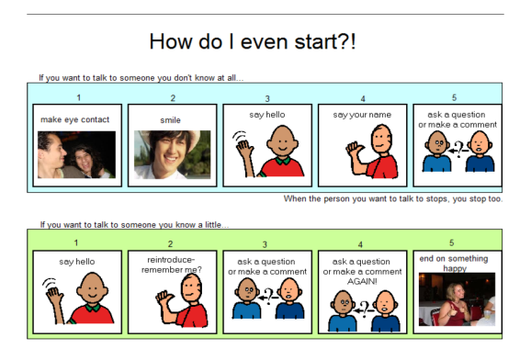

Activities this Week

Establish Safety and Comfort
Because we may be addressing some difficult topics, it is really important for us to set a tone for the group and help participants feel comfortable. All the activities this week touch on this objective.
B
For Participants to Get to Know One Another
Specifically, we would like each member of the group to know the names of each of the other members of the group. Many of the activities this week focus on sharing. Our goal is for each member of the group to have shared one piece of personal information about themselves.

Name Cards
Each participant will be asked to decorate a name card with words, drawings, and pictures from magazines. On the outside of the card they will put descriptors that they think everyone sees. On the inside they will put descriptors that people may not know about them. The name cards help promote self-reflection. The private/public self is a complicated topic. Students might not fully grasp this idea during this session but we will return to it throughout the group.

We Can Use Your Help!

Next Week …Anatomy
- Go Over Schedule
- Parts and Post-it Notes
- Terminology
- Fruity Anatomical Models
- Breakout Session
- Closure

Defining Sexuality
We ask participants to come up with their own definition of sexuality. By facilitating the participants coming up with the definition we give participants power and control over the class. It also allows the facilitators to assess previous learning and understanding.

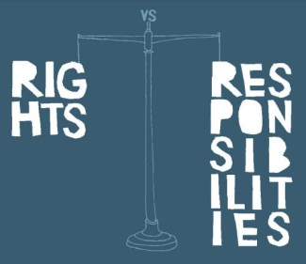
This week, the main area that we could use your help with is reinforcing our Rights and Responsibilities at home. Is this language that you may be able to incorporate? Could you “call your kids out” when you noticing them doing a nice job listening and being respectful? Our group Rights and Responsibilities are: to be heard, to ask any questions, to not be put down, to pass, to not have assumptions made about you, to have your own feelings, to say hello and good-bye to group members, to be present and confidentiality

We will be coming up with our own definition of sexuality in this group, but we rely on a definition of sexuality education from the Sexuality and Information and Education Council of the United States (SIECUS) that we wanted to share with you.
Sexuality education is a lifelong process of acquiring information and forming attitudes, values, and beliefs about identity, relationships, and intimacy. It encompasses sexual development, reproductive health, interpersonal relationships, affection, intimacy, gender roles and body image. Sexuality education addresses the biological, socio-cultural, psychological, and spiritual dimensions of sexuality from the cognitive domain, the affective domain, and the behavioral domain.
www.siecus.org is a great place to start getting more information about human sexuality. We especially like their guidelines for developmentally appropriate messages related to a comprehensive list of sexuality topics.

Research:
In a parent focus group on the topic of sexuality and their children with ASD several interesting themes emerged: parents struggle with what healthy sexuality looks like in their child with ASD, they feel their child’s social impairments make many sexuality topics difficult to understand, they feel the community does not understand the sexuality needs of their child, and they feel unprepared to support their child with their sexuality needs.
Does that sound like you?
These researchers made several suggestions for parents.
1) Lean about sexuality and ASD as well as sexual development in general.
2) Think about your hopes and fears for your child. Also think about your own experiences learning about sexuality.

Additional Resources
3) Set goals for your child (and we would maybe modify, to the degree that they are able, with your child).
4) Think about the method to communicate these messages to your child.
5) Coordinate with schools, physicians, ect.
We have found a book that may be useful called “Adolescents on the Autism Spectrum: A Parent’s Guide to the Cognitive, Social, Physical, and Transition Needs of Teenagers with Autism Spectrum Disorders “. You can get a pretty good preview on Google books to make sure it is right for you. We like it because it talks about ASD in general and then weaves in topics related to puberty. It also thinks about changes from multiple domains.
