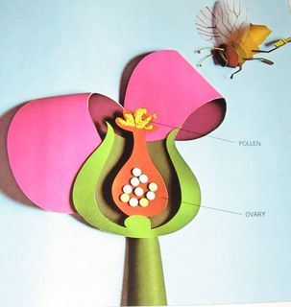
  Human Sexuality 101
    - Anatomy
    - Issue Date
the autism program at urbana-champaign |  | Objectives this week

Parts and Post-it Notes
We’ll start the group out by having them label body parts they already know. By starting out with safe, comfortable body parts students will be more prepared for unknown body parts or parts that may cause feelings of anxiety.

Terminology

Next Week …Puberty
- They Tell Me I’m Going Through Puberty
- Boys/Girls/Both
- Puberty Changes Worksheet
- Diversity
- Breakout Session

We’ll introduce sexual terminology in written from and ask the students to say the words out loud. Between each word we’ll pause and they will have a worksheet with the question “I feel…” Reading a word and saying it are easier then looking at a body part so we are building their comfort level. Also, feelings of embarrassment can be difficult for students to manage. This is structuring a way for them to think about and express their feelings.

Fruity Anatomical Model
The students will make anatomical models of the reproductive organs using fruit. As they make the model, we’ll talk about the function of each part. Again the fruit makes the concept a little more abstract and safe. This is a fun way to engage students in what is essentially a vocabulary task.

Privacy
We introduce the concept that privacy is about personal things you want to keep to yourself and explain that the parts of the body we were just talking about were private body parts. We will also introduce that certain places are private, that you share with different people private information or ideas, that ideas can be private. The main distinction is that there is a difference between private and public but we present three levels to indicate that there is a continuum of privacy. Students may struggle with what a private idea is.

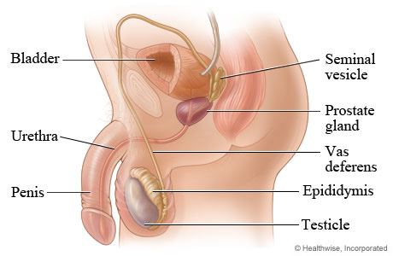

Activities this Week

Terminology
We will expose students to anatomically correct terms for body parts involved with human reproduction. We expect students to be able to name at least three parts and their function. We expect students to be able to express their emotions when exposed to these terms when provided with support.
Privacy
We will introduce the concept of privacy. We expect that students will be able to name people and places at two different levels of privacy although we will expose them to the idea that there could be multiple levels of privacy.

Terminology

We Can Use Your Help!
The tubes that carry sperm from the epididymis to the urethra.
Makes a discharge which lines the urethra to protect sperm.
Finger like parts that which find an egg and sweep it into a tube.
The neck of the uterus.
A soft area of skin enclosed by the labia.

Vulva
Vas Deferens
Cervix
Fimbria
Cowper’s glands

Can you match the term with the function?
Each family makes their own choice about whether to use technical language or to use common language when referring to sexual body parts. Your kids really need to know both. Goofy names or names just your family uses might be confusing.

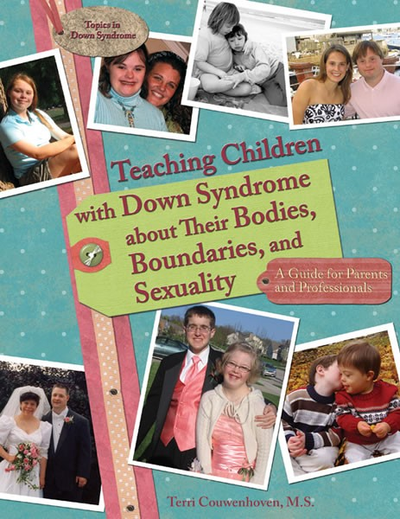
Privacy
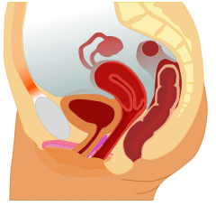
It can feel uncomfortable to give your child private space and private time, but this can be a good way to reinforce this concept. It also allows them more independence but it’s important to do so in a structured controlled way. Is there a time of day and a space that they could have to themselves to be undisturbed? Maybe introducing a journal where they can write down their private ideas? This may or may not be a place where they are exploring their sexuality but it will give them some autonomy.
Emotions

Additional Resources
Embarrassment and jealousy can be difficult emotions to recognize and express but are also really common in adolescence. Your children may need support naming these emotions and thinking of appropriate outlets.

The book “Teaching Children with Down Syndrome about their Bodies, Boundaries, and Sexuality” is a great resource. There is a lot of good information that is relevant to all children. They have wonderful pictures and tips for talking about a wide variety of sexuality topics including body parts and privacy.
Autism Now isn’t specifically focused on topics related to sexuality but they do have some great resources I thought I could highlight. They have a series of webinars related to sexuality topics. In addition to the webinars they have some general “fact sheet” style info that might be helpful on topics such as dating, marriage, divorce, relationships, sexuality, parenting, and friendships. These include general information as well as parent tips. I was really impressed by the quality and quantity of ASD related resources on a variety of topics so it’s a good one to have in your tool belt. http://autismnow.org/
The Institute of Disability and Human Development at UIC has a Sexuality and Disability Consortium that provides support for individuals and families. They have a few resources on their webpage but are also folks who may be able to provide more support with any problems that may present themselves in the future around sexuality topics. Their website is http://www.idhd.org/SDC.html

