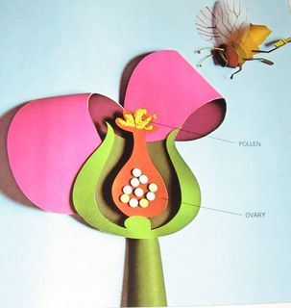
  Human Sexuality 101
    - Puberty
    - Issue Date
the autism program at urbana-champaign |  | Objectives this week

Defining Puberty
This is the language we’re using to define puberty: puberty is your body changing from a child’s body to an adult’s body. It causes changes to your body inside and outside. Everyone goes through puberty but it might happen at different times and people’s bodies change to look different. Puberty is a time when you start to get sexual feelings. You don’t have control over going through puberty, but you do have control over how you react to it. It’s normal to have mixed feelings, some good feelings and some negative feelings. This definition highlights several key features of puberty (it’s in some ways different and some ways the same for everyone, it’s a natural biological process, it can be an adjustment).

They Tell Me I’m Going Through Puberty
This is a story told from the point of view of a teenager about the changes that are happening during puberty. This exercise helps students to understand that many of the changes that are happening in puberty happen to both boys and girls. The narrative format may help students relate to the changes that are occurring.

Boys/Girls/Both
In this activity, participants are given a series of cards each with a change that happens during puberty. They decide if these changes happen to boys, girls, or both. Again, this exercise helps students to understand that many of the changes that are happening in puberty happen to both boys and girls. Many of these changes are repeated from the first exercise although more are introduced. Each card separates out each change as concrete steps.

Puberty Worksheet
This worksheet is a check in on the changes participants have experienced, how they feel about these changes, and changes they anticipate. The worksheet is designed to help students anticipate some of the changes that will happen during puberty and help them to be aware of the changes that are happening in their own body. We use both open ended and multiple choice questions to stimulate different levels of thinking.



Activities this Week

Defining Puberty and Normalizing Differences
Participants will understand what puberty is and recognize that there are many similarities in the kinds of changes between genders and various people during puberty. 
Understanding Changes
Participants will identify at least three physical or emotional changes during puberty.

Diversity
We will show students power point slides with pictures of several people showing a diversity of bodies and ages. Students are asked, “Which ones are going through puberty?” This activity reinforces the concept that puberty is in some ways different and some ways the same for everyone. This also helps create a visual picture for the changes that are happening during puberty.

Conversation Topics- Puberty

Next Week …Reproduction
- Go Over Schedule
- Reproduction Video
- Breakout Session
- Closure

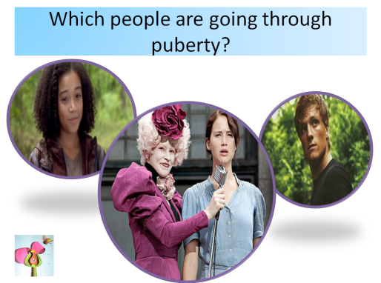

Would you feel comfortable answering these questions with your child? What was the first sign you noticed that you had started puberty? How old were you? What was the best thing about puberty? What was difficult about puberty? How did you handle the difficult parts of puberty?
There’s a great puberty video available from the Discovery channel that you can watch for free on You Tube called Teen Dreams. They a really nice job of connecting the internal (structural and hormonal changes) with changes you can see (physical, behavioral, and emotional). This would be a great video to watch and discuss together.

Additional Resources
So, what’s your plan for managing menstruation (parents of boys luck out on this one)?
Klett & Turan used a combination of three Social Stories adapted from Mary Warbol’s “Taking Care of Myself: A Hygiene, Puberty, and Personal Curriculum for Young People with Autism” (this book is not just for girls). They implemented the social stories before menarche (first period) and then planned to revisit them after menses began. These stories focused on growing up, what a period is, and how to take care of a period (I would reprint them but you have to be careful about Social Stories and their copy rights). They also used simulations with the girls using red syrup so they could practice changing a “used” menstrual pad. They reviewed the social stories over several days and completed simulations over several days. They also used different types of menstrual pads in case the girls did not always have access to the same type. They also asked the children questions about menstruation to check for comprehension (such as “What is the blood from your vagina called?” and “Do you need to wear a pad when you don’t have your period?”). This method proved effective in these case studies and the parents who implemented the plans where happy with it.
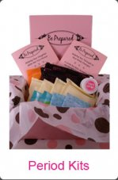
I have a good friend who made a menstrual kit for his daughter to start keeping in her book bag around age 11. In a zip lock bag he placed a change of under ware, menstrual pads, Tylenol, a change of shorts, and bathroom wipes. That way if her fist period was at school, she had everything she needed and wouldn’t need to ask for support unless she wanted to. I personally think this is a wonderful idea and wish my mom had thought of it when I was middle school! This idea has caught on because you can buy pre made kits.
I have heard that some families also preemptively use pain relief to support with discomfort and PMS. Not all girls associate the physical discomfort with their period or are able to communicate “I feel bloated” or “I have cramps”. Although these are phrases that you can teach and prompt, some families just start using an over the counter pain killer two or three days before they anticipate the start of the period. This isn’t full proof because, especially when girls first start getting their period, they may have irregular cycles.

In Short- The 4 P Plan for Period Support
- Prepare a period kit
- Pre instruct (perhaps using social stories)
- Practice
- Plan for pain relief

