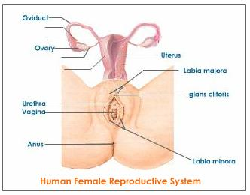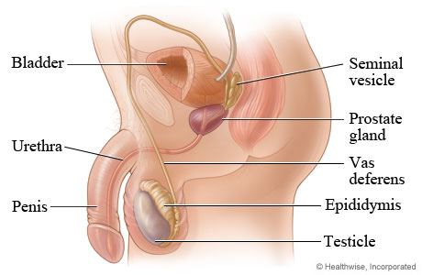
Human Male Reproductive System

When I hear these words I feel…

I feel…
__________________________________________________________________________________________________________________________________________________________________

I feel…
__________________________________________________________________________________________________________________________________________________________________

I feel…
__________________________________________________________________________________________________________________________________________________________________

I feel…
__________________________________________________________________________________________________________________________________________________________________

I feel…
__________________________________________________________________________________________________________________________________________________________________

Privacy

Is something personal, something you keep to yourself, something you don’t share or share with a few people.

