Next Week …Dating
- Go Over Schedule
- What is a crush?
- How to deal with a crush
- Turning someone down
- Breakout Session
- Closure


  Human Sexuality 101
    - Reproduction
    - Issue Date
the autism program at urbana-champaign |  | Objectives this week

The Miracle of Life

We’ll use “The Miracle of Life” to explain the process of reproduction. As the students watch the video they will fill out a worksheet. The worksheet helps students tune in to ambiguous language that we use to describe sex (like miracle, chemistry). It also helps them break down the steps of the birth cycle. The video outlines each of the steps of reproduction, describes them, and visually shows each step of prenatal development.

Conversation Topics- Birth Control
You may think that your child is not sexually active so birth control is not something that you have to worry about. There are a few things to keep in mind.
1) You may not always know if your child is sexually active or not. Ideally you and your

child would share similar values about the timing of sexual activity and they would feel comfortable coming to you. However, young people sometimes go to great lengths to hide their sexual activity from their parents. How do you communicate your values about sexual activity?


Activity this Week

The Steps of Reproduction
We hope students will have an understanding of the steps of reproduction. Although they may not know all the steps we focus on intercourse, fertilization, implantation, the embryotic period, the fetal period, and birth. Additionally, we will reinforce the concept that intercourse can cause reproduction.

2) Although it’s not common, one of parents’ greatest fears is the possibility that their child could be taken advantage of. Furthermore, despite education they may not fully grasp the implications of their choices. How do you promote safety without instilling fear and shame?

Wanting to be a parent is a natural urge that most people experience. These urges can be difficult to manage especially if the person needs some level of support to be independent. Because someone has a diagnosed disability, people often feel that they have the right to question that person’s ability to be a parent. What makes this especially tricky is that in some cases those concerns might be valid. You may be asking yourself the question, “Will my son or daughter be capable of having children one day?” Many people with disabilities are capable of being excellent parents. No parents can raise children 100% on their own; everyone needs help sometimes. On the other hand it is easy to get wrapped up in the joys of having a child without thinking of all the sacrifices and responsibilities. What are your hopes and fears about your child as a possible parent? What do you need to do to support your child with making the best choice for them?

Conversation Topics- Parenting

Additional Resources

Where to get more information about birth control…

PlannedParenthood.org has some of the most up to date and comprehensive information about birth control options.
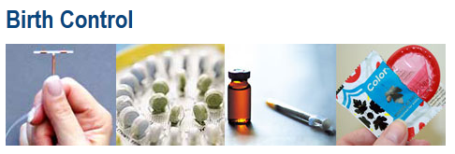

TeachingSexualHealth.ca has a nice webisode about how to address contraception with your child (in addition to other resources).
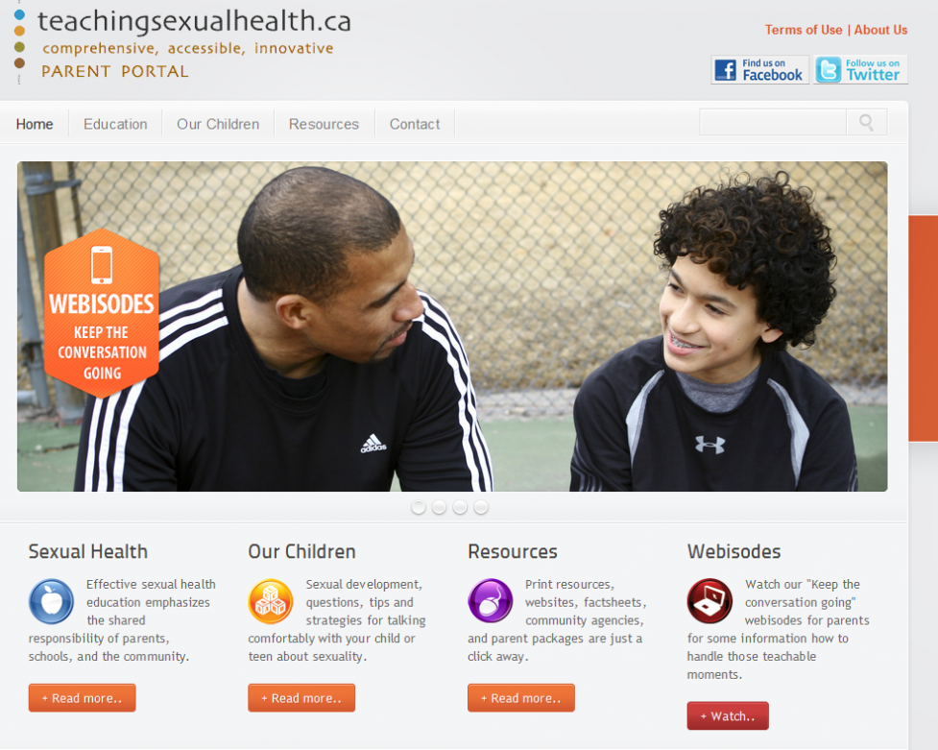

Where to get more information about individuals with disabilities as parents…

AutismNow.org has a lot of great resources for families Autism including several webinars about sexuality topics. They have webinar presented by self-advocates about being parents. Below is one of the slides from the webinar.
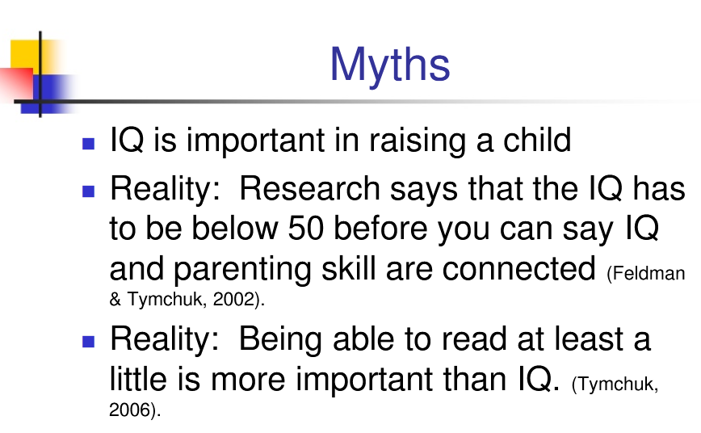
There is also a documentary called Is Love Enough? that you may find interesting. This movie shares one couple’s story.


Where to hear about what other parents are going through…

AThinkingPersonsGuidetoAutism.blogspot.com is a blog by people with Autism, family members, and professionals. Most of the articles are not about sexuality but I find those that are to be very insightful.
