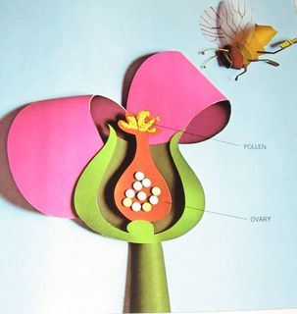
  Human Sexuality 101
    - Hygiene
    - Issue Date
the autism program at urbana-champaign |  | Objectives this week

Hygiene Olympics are a series of interactive stations designed to emphasize the importance of hygiene, provide opportunities to practice hygiene tasks, and potentially introduce new elements of hygiene routines.

Hand Washing
Students will sprinkle glitter on their hands and then have to wash their hands until the glitter comes off. This will help students to recognize that hand washing is more than just rinsing hands lightly with water.

Body Washing
We will have life-size body outlines, loofas, and paint. Students will use the paint like its soap. This will help students recognize the importance of washing their entire body.

Laundry
Students will see a pile of laundry. They will have to sort the clean from the dirty clothing (the dirty clothing are just tee shirts that have been dampened and wrinkled). This will help students identify clean clothing.

Deodorant Testing
We will have several deodorants with the brands blocked out. Students will smell and vote on their favorite scent. At this station, teachers will point out the importance of wearing deodorant each day and reapplying after activities that cause sweat. This station will emphasize the importance of deodorant use.

Shaving
Students will use and orange to practice shaving with a razor and shaving cream. The teacher in the group will explain that boys often shave their face and that girls often shave their legs and underarms. Students will have an opportunity to practice shaving.

My Hygiene Routine
Students will see pictures of different hygiene tasks. They will have a worksheet that says “My Hygiene Routine”. Students will choose what order they would prefer to complete the hygiene tasks.

Activities this Week
Hygiene Olympics

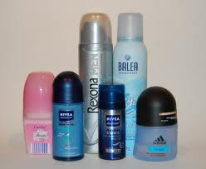
Understanding the Importance
Throughout Hygiene Olympics, we will stress the importance of regular hygiene. We expect that students will verbally indicate that they understand the importance of hygiene.
B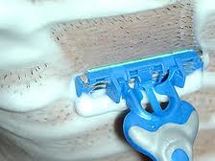
Practicing Tasks
We will provide students with opportunities to practice hygiene tasks. As they practice, we expect students to gain a basic understanding of the components of hygiene.

Next Week …Wrap Up and review
- Go Over Schedule
- Vote with Your Feet: Fact and Opinions
- What Have I Learned?
- Group Evaluation
- Breakout Session
- Closure

Letting Kids Choose

Maybe hygiene is an area where your child already has a lot of control, but if not this can be a great area to make room for more autonomy. Consider letting your child choose: toothpaste flavor, hand soap, body wash, deodorant, laundry detergent…
It can also be an area to introduce more responsibilities- like doing their own laundry or purchasing personal care items independently.

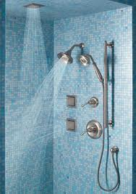

My Kid Won’t Shower!

It’s pretty normal for adolescents to react to some of the changes in their body by refusing to shower. They may be feeling uncomfortable with these changes. It can also be that they are producing more oil and different smells and aren’t adjusting with changes to their hygiene routine. To complicate matters, your child may become very embarrassed if you try to bring up hygiene issues. So what can you do?
To start with, establish a good hygiene routine before some of these changes start happening. Also, during a calm relaxing time (not in the morning right before school) sit down and establish the tasks your child needs to complete each day and what order they want to complete them in. It’s not a bad idea to write it down and keep it posted somewhere visible, but fairly private. If things get extreme, you may want to set up a reinforcement system for completing the hygiene routine.

Additional Resources
www.asdsexed.wordpress.com
th

From Linda Hodgdon at www.usevisualstrategies.com

What is a Visual Strategy?
Visual Strategies are things that we see. Body movements, environmental cues, pictures, objects and written language can all be used to support communication. Our environment is full of signs and logos and objects and other visual information that supports communication.

Why Use a Visual Strategy?
They help communicate information to individuals. They help people organize their thinking. They give choices and communicate rules.

How to Use a Visual Strategy?
There are lots of options. Schedules and calendars are the most common visual tools used to give individuals information. They can be as detailed or simple as needed. Sometimes people use objects, other times pictures and words, and sometimes just words. You can combine the prompts with a check off system, remove items using Velcro or magnets, or cross items off a list. TAP can help you create a visual strategy to meet your child’s needs!
