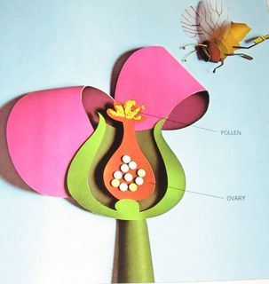
  Human Sexuality 101
    - Body Image
    - Issue Date
the autism program at urbana-champaign |  | Objectives this week

What is Body Image?
We’re using a pretty simple definition of body image: how you think and feel about your body and appearance. This definition highlights the cognitive and affective components of body image.

Body Stories
Each student will read a body story about how a person feels about his or her body. The students highlight certain words and phrases the author uses to express his or her body image. After they are finished, we will discuss what everyone highlighted. This activity will help students understand that people feel a lot of different ways about their bodies and that these feelings change over time.

Body Image Facts
We will discuss several facts related to body image. These facts will provide students with information about body image and raise awareness about how common it is to have a negative body image.

Media
We will talk to the students about how the media alters images to create unrealistic expectations for our bodies. We will show the distorted beauty video that illustrates how an advertising image is made. After the video we will have a discussion and emphasize the importance of having a realistic and positive body image.

Self-Portraits

Next Week …Crushes
- What is a crush
- How to deal with a crush
- Asking someone out
- Turning someone down

Body image is one of those topics that is not just about learning facts, but mostly about self-awareness and self-expression. In addition to teaching some concrete strategies for promoting positive body image, we also want to provide opportunities to explore thoughts and feelings about appearance. The self-portraits are another strategy for helping students explore their thoughts and feelings about body image.
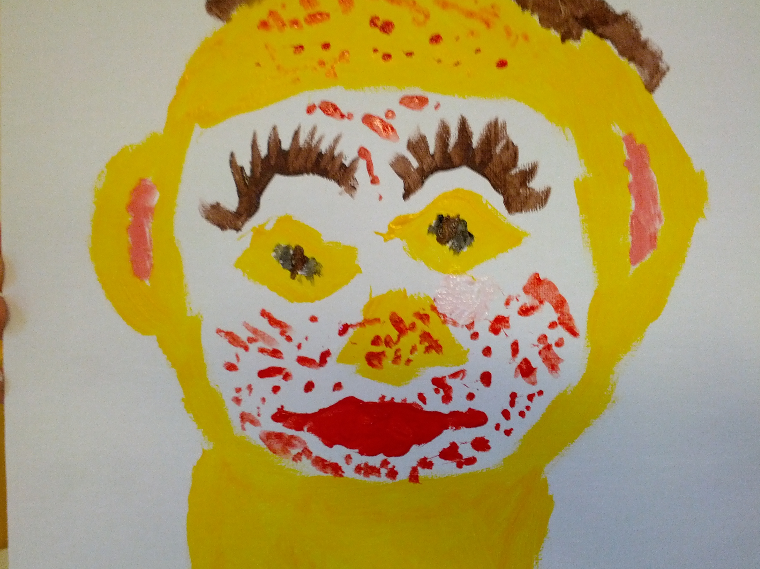

Activities this Week

Awareness and Expression
We want students to be more aware about how they think and feel about their bodies and appearance and to have outlets for expressing these thoughts and feelings. These outlets can be verbal, through the written word, or artistically. 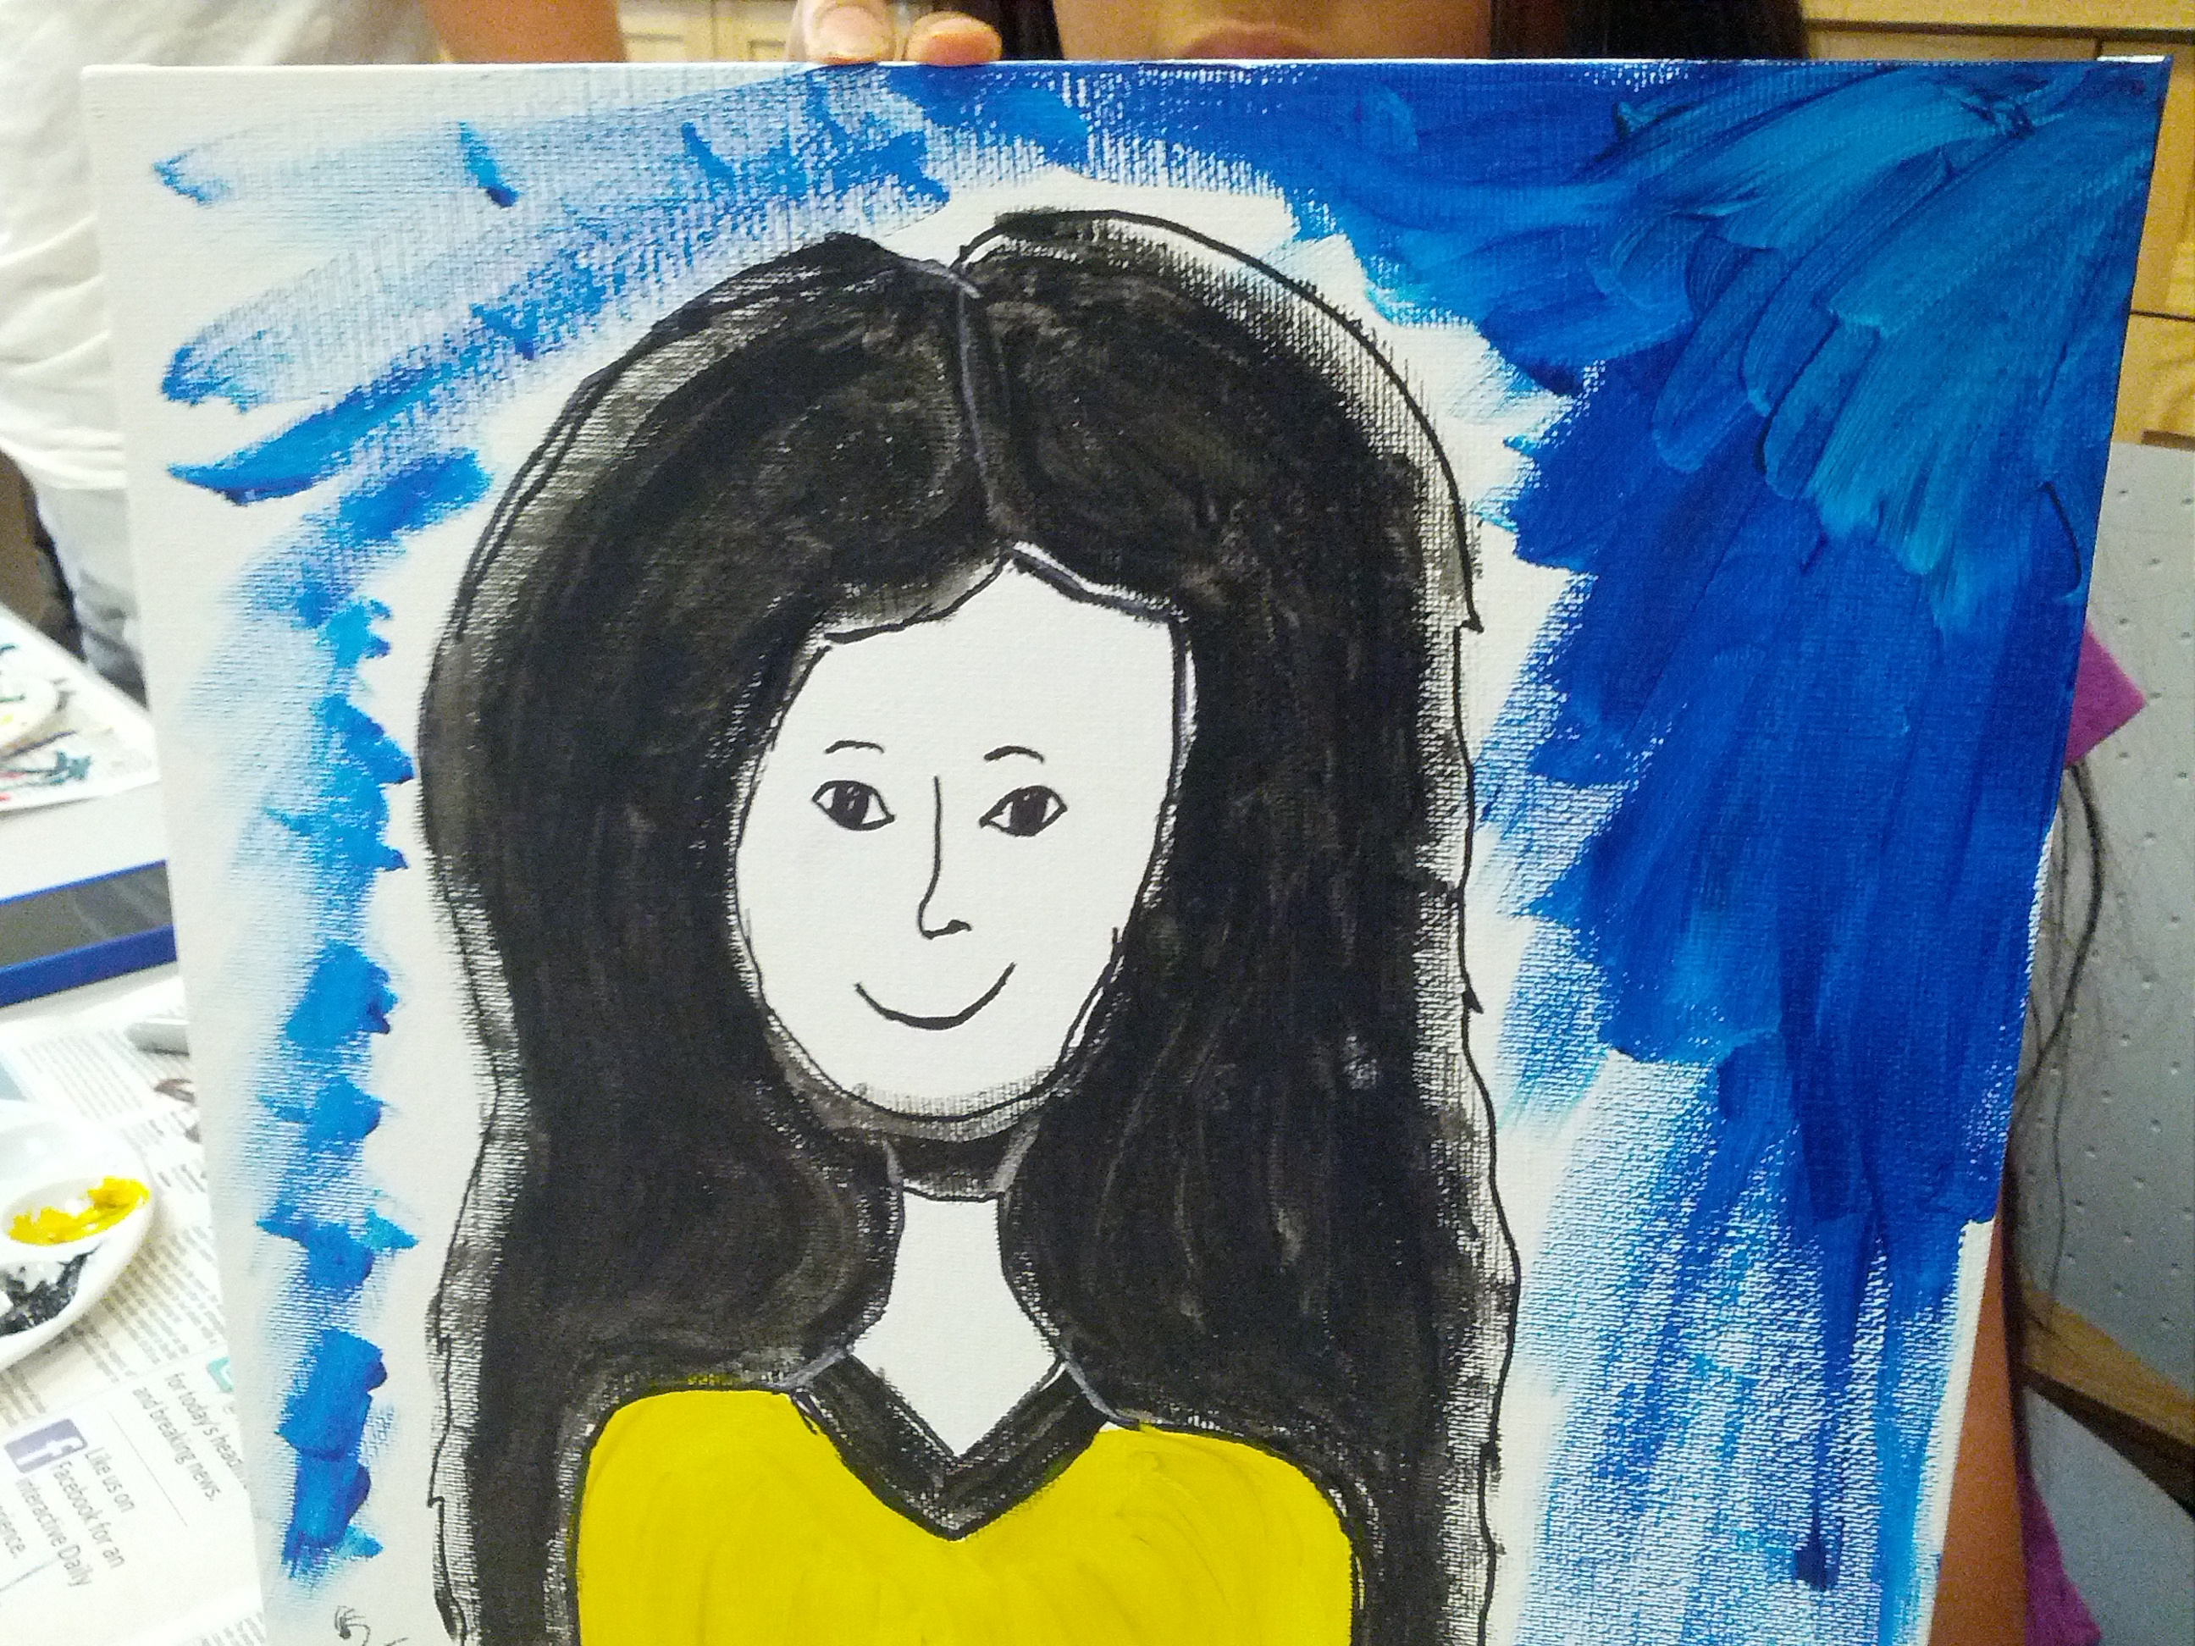
Strategies
Students will be introduced to a strategy for promoting a healthy body image. We expect that they will be able to use this strategy with support.

As parents, you can help your child build a positive body-image. There are many aspects of life that factor into whether or not a person has positive body-image including the way a person talks (and thinks) about their body to themselves and others. In our group, we focused on positive self-talk as a strategy for building a healthy body image, but in our culture it is much more common to use negative self-talk. This is often referred to as “fat talk”. Although it is called “fat talk” it refers to all the negative statements we make about our body, appearance and self. These statements can be inside your head or out loud. We often think about “fat talk” as only being a concern for women and girls, but men and boys also engage in “fat talk”. As parents, you can help your children disengage in “fat talk”.
“Fat talk” or negative self-talk can be tricky for several reasons. For one, it has become a normal part of speech for most people. So much so, we do not even realize when we are doing it (you could do a mini social experiment just trying to catch people using “fat talk” and see how prevalent it is). Because it has become normal, in social groups it can be a way of connecting. It can be really difficult to disengage in “fat talk” in social settings.
Having said that, there are several things you can do. One way for you to help your teen is to begin recognizing these statements in yourself. Often, when we look in the mirror, our initial reaction is to put something down about our bodies. Sometimes, when we hear someone else put down their bodies, we engage in fat talk as well automatically (this doesn’t mean saying “oh, yeah you are fat” but rather participating in a conversation based on criticism). Pay attention to when this happens and try to stop yourself from doing this. Try to force yourself to tell yourself something that you like about yourself and your body, even if you don’t really believe it. Once this begins to become a habit, your teen may pick up on these, just as he or she will pick up on you putting yourself down (if your teen hears you putting yourself down they may be more likely to put themselves down and feel criticize). They hear more of what you say than you think, so modeling this positive self-talk and putting an end to fat talk in your home can help influence your teen to build more positive body-image.
In addition to modeling, you can also “call out” your teen if they are engaging in fat talk. For example, if your teen says, “I hate my nose, it is so ugly!” rather than saying, “No its not. Your nose is beautiful!” try to say something like, “You know, you are being kind of mean to yourself and that can make you (and others) feel bad. Tell me something you love about yourself or your body. There are so many things that I love about you!” It can seem counter intuitive to not directly correct the “fat talk” but when you say “No, you’re beautiful” you are still engaging in the “fat talk” cycle. By “calling them out” you are breaking the thought cycle.

Additional Resources

We need your help!
Unfortunately, there is very little information about body image specifically developed for individuals with ASD and even developmental disabilities in general and little (if any) research in this area. However, difficulties with body image are well documented throughout adolescence so there are some good websites to provide parents with guidance for supporting teens.

About Face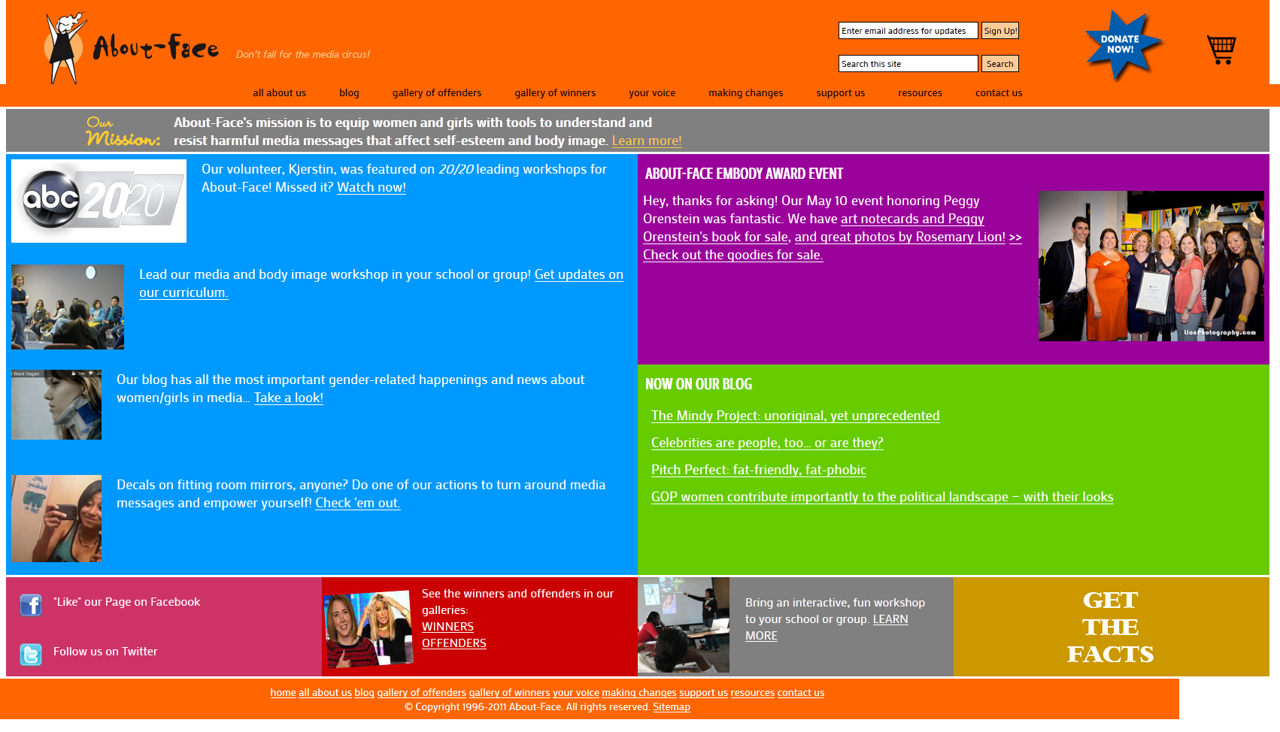
http://www.about-face.org/ information about body image and the media. They have action plans for advocacy.
Palo Alto Medical Foundation 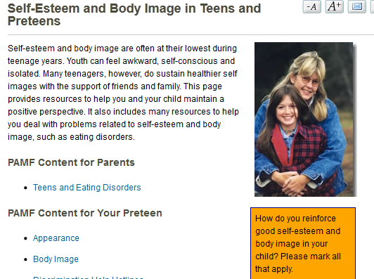http://www.pamf.org/parents/general/selfesteem.html has a great list of additional resources so you can connect with more information than we provide here. One of the things I really like about the site is that they break down information about body image by age group.

For Girls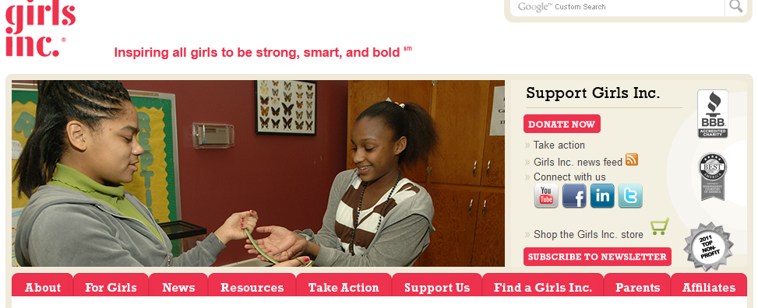
http://www.girlsinc.org/ is a great resource for promoting a positive self-image in young girls.

For Boys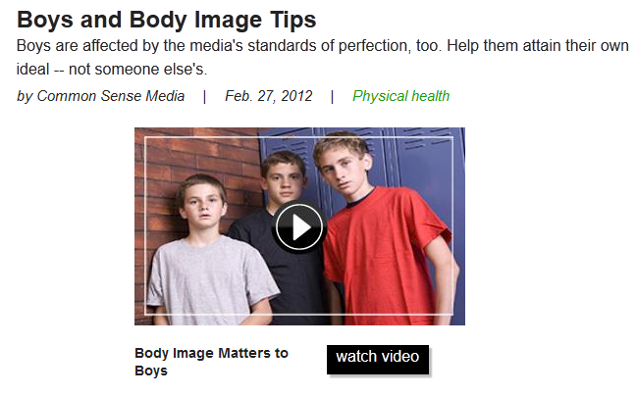
http://www.commonsensemedia.org/advice-for-parents/boys-and-body-image-tips has information and videos for supporting boys with body image.

