What We learNED THIS WEEK...
  - Community Choices

Connections

Welcome to the first session of the Connections class being offered by Community Choices in partnership with the Autism Program at the University of Illinois Urbana-Champaign!
This week we went over some important topics that will be covered throughout the course of the class. The group created a list of Rights and Responsibilities. These will help us to establish safety and serve as a guideline for knowing what is expected in the
group. They are also good guidelines for boundaries in everyday relationships.
We also established a question box, a tool that can be used at any time throughout the course to ask questions. The question box is anonymous, meaning no one will know who asked the question.
Everyone has a more private version of themselves and a more public version. We made name cards and wrote on the inside and outside parts of the folder. On the inside, we wrote about things that nobody could see, or our private selves. On the outside of the folder, we wrote about the part that everyone sees and described ourselves the way we think everyone sees us.
Our icebreaker was move your boodie, a fun way to get to know each other and find out more about our other classmates!

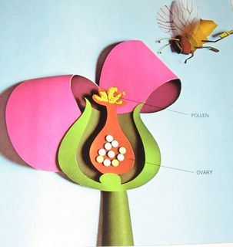
weLCOME: wEEK 1
oBJECTIVES tHIS WEEk:

- eSTABLISH sAFETY AND COMFORT

- gET TO KNOW OTHER GROUP MEMBERS

- kNOW THE RIGHTS & RESPONSIBILITIES OF THE GROUP

Defining Sexuality

As a group this week, we made our own definition for sexuality. We thought of three words that we think of when we hear “sexuality.” Then, we thought of who we talk to about sexuality. Is it our friends? Our parents? Think about who you talk to about sexuality and how that may impact your view. Finally, we were able to define sexuality and have a better understanding of that concept.
The Circles of Sexuality by Dennis Dailey, Ph.D. (1981) help show all the different aspects of sexuality. Sexuality can be broken down into: sexualization, sensuality, intimacy, sexual identity, sexual health and reproduction.
Each person’s values determine what they believe about these Circles of Sexuality.
For next week, think about these Circles of Sexuality and how your values connect to them.
Make sure to have a look at the Circles of Sexuality worksheet we have attached at the end of this newsletter.
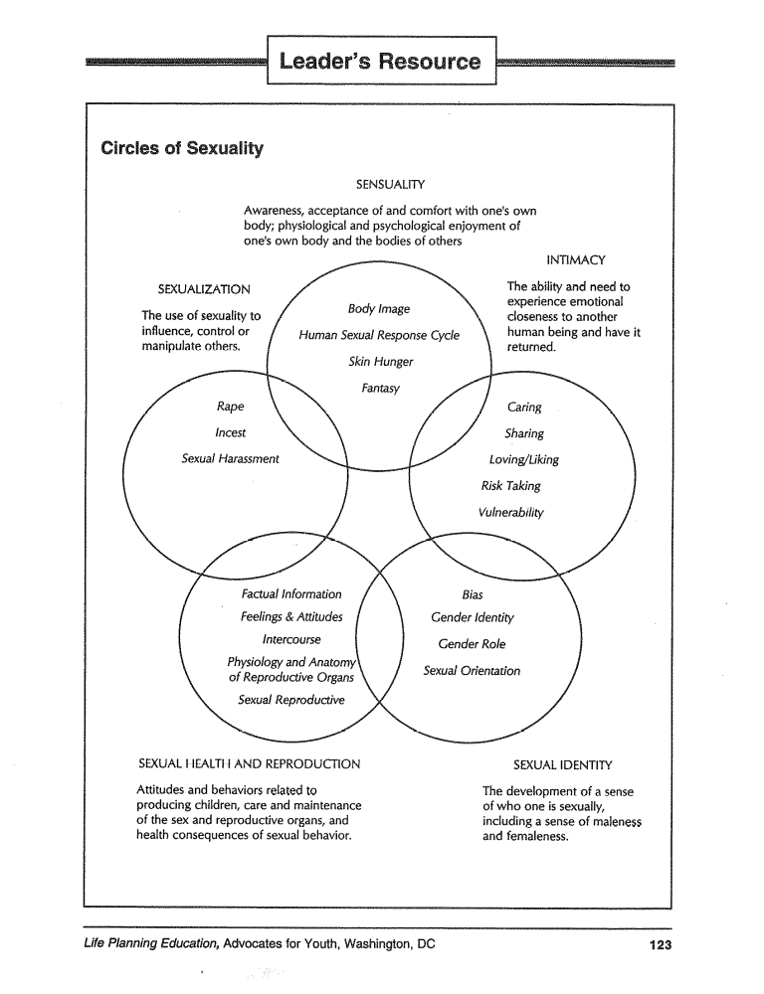
Relationship Pyramid
The Relationship Pyramid can help you visualize what types of relationships we will be talking about in this class. This visual can help you in understanding the different relationships in your life and how to act how others expect you to act in those relationships. As you can see, the bottom relationship, friendly acquaintances, does not include much physical contact. As you move further up the 5-point scale, the intimacy level of the relationships increases. For next week, think about the relationships you have in your life and who would fit into these different categories.
Circles of Sexuality by Dennis Dailey Ph.D. (1981)

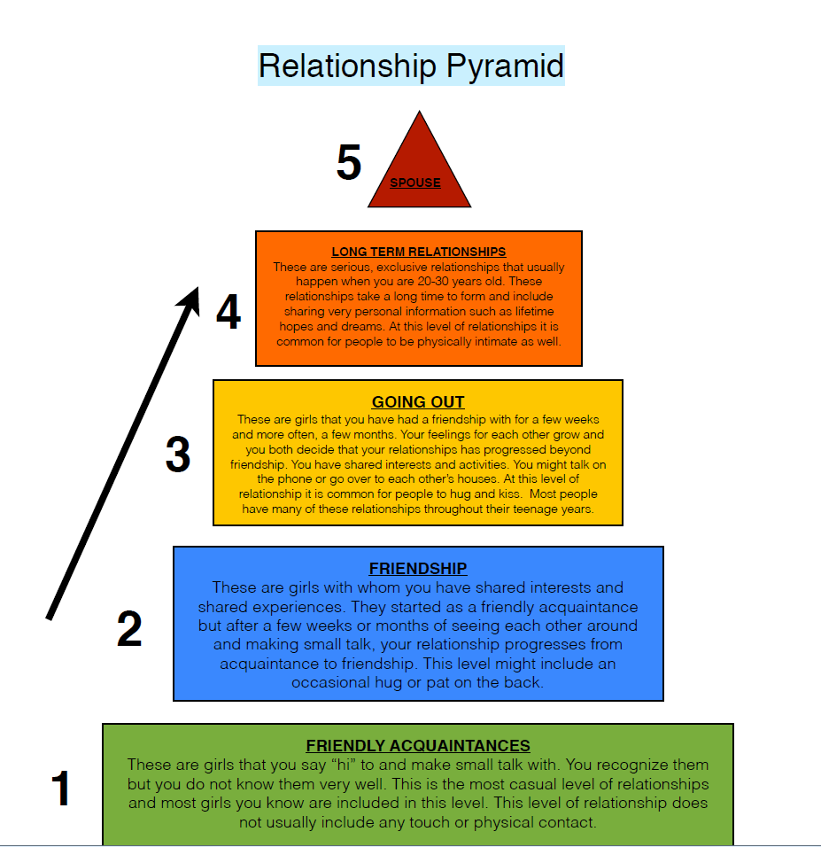

Next Week (Tuesday, February 19th):
We will review everyone’s names, go over what we did this week, and discuss our chosen topic.

To Do For Next Time…
- If you have a question, bring it and put it in the question box!
- Think about the Circles of Sexuality and how they connect to your values.
- Think about the Relationship Pyramid how you would use it.
Additional Resources:
This website – www.asdsexed.org – provides additional resources, curriculum, general information, tips, policy examples and visual supports for teaching sexual education. This website provides resources for helping teach human sexuality to individuals with special needs. This is Sarah’s website and can be a very helpful tool for you on many different subjects.

Another great resource is: http://siecus.org/_data/global/images/TalkAboutSex.pdf - This is a PowerPoint presentation that has a great overview on many different sexual issues. This website covers basic biology, gender identity, relationships and more!

