What We Learned
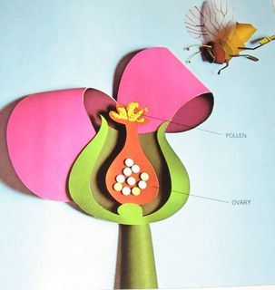
  - Community Choices

Connections

this week…
This week we talked a lot about “What is a crush?” Together, we worked as a group to define a crush, who can be a crush, and how to act when you have a crush.
We also talked about the difference between lust and love. Lust is usually when you have some physical attraction to someone, but not necessarily like them emotionally. Love, on the other hand, is usually when you like someone emotionally and would like to be romantically involved with that person. You may also be physically attracted to them.

Week 3
Objectives
- Know what a crush is and be able to recognize those feelings
- To understand the difference between lust and love
- Better understand when it is to approach someone you like and how
- Know ways to say “No” to someone you do not want to get involved with

Most of our class this week focused on a flow chart that we used to help us determine what to do in different situations with a crush. We thought about ways to meet someone, how to talk to someone you like, and places to go on a date, like getting coffee together.
We also talked about what to do if someone does not like you back. We talked about how to give others space and how to deal with the sad feelings.
Finally, we talked about a situation where someone likes you but you do not like them back. We talked about nice ways to say “no” and different strategies you can use to politely turn someone down if you are not interested in becoming involved with them.
For Next Week:
We will be talking about dating and relationships. We will discuss finding a partner and how to be with someone that is a healthy match for you. Relationships and dating can be complicated – we, as a class, will try to understand it better.

Love Vs. Lust
Love takes a long time to develop. Lust develops intense feelings quickly.
Love can last a long time. Lust is usually short-lived.
Love is powerful. Lust is desire.
Love lets you be yourself. Lust is more focused on each other’s bodies.
Love accepts the other person’s flaws. Lust involves passion and drive.
Love is more than physical attraction. Lust is all about physical attraction.
Love makes you happy. Lust makes you satisfied.

Additional Resources:
This article - http://www.wikihow.com/Build-Self-Confidence - is a funny sequence of pictures that show how you can boost your self-confidence. When you have a crush or want to start dating, it is important that you believe in yourself. This article has some good tips to show how you can build your self-confidence.

The book What Men With Asperger Syndrome Want to Know About Women, Dating and Relationships by Maxine Aston has a great section about dating and courtship. Unfortunately, this book is aimed only at men. Questions are answered like, “How do I know if she is attracted to me?” and “What should I talk about on a first date?” Men, we think this could be an informative read for you in preparation for next week’s topic of dating and relationships. This book is available at the Autism Program on the corner of Nevada and Lincoln in the Doris Kelley Christopher Hall. The 2Red and 22Illini bus lines stop close by the Autism Program if you are interested in visiting and checking out the book!

