What we learned this week…
  - Community Choices

Connections
This week we learned about power in relationships. We talked about the benefits and drawbacks to having a lot of power in a relationship, specifically a romantic relationship. We also discussed the benefits and drawbacks to having less power in a relationship. It can be helpful to think about the good and bad aspects to power because it helps us to understand the dynamics of adult relationships.
We also talked about why the balance of power in relationships is healthy and should be equal. Often, when power is balanced between two people, both individuals will feel satisfied in the relationship.
Finally, we discussed that when power is unequal, it can lead to negative consequences, like abuse. Unequal power and control is not only physical abuse, but can also be sexual, emotional, or mental.
Week 5
Power in Relationships
Objectives:
- Better understand what a healthy and equal relationship dynamic looks like.
- Learn how power can affect self-esteem and confidence.
- Know ways to handle difficult relationship situations and understand what you would try to do in those scenarios.

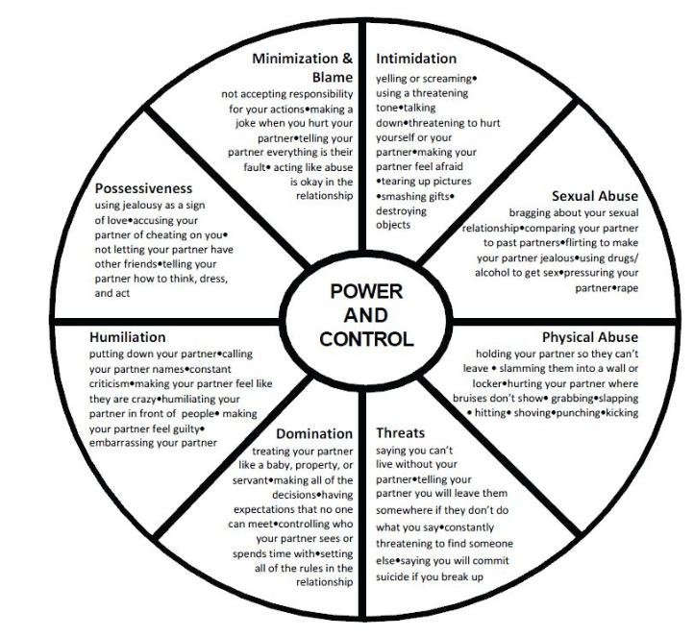
From http://www.stepupspeakout.org/youth/wheels
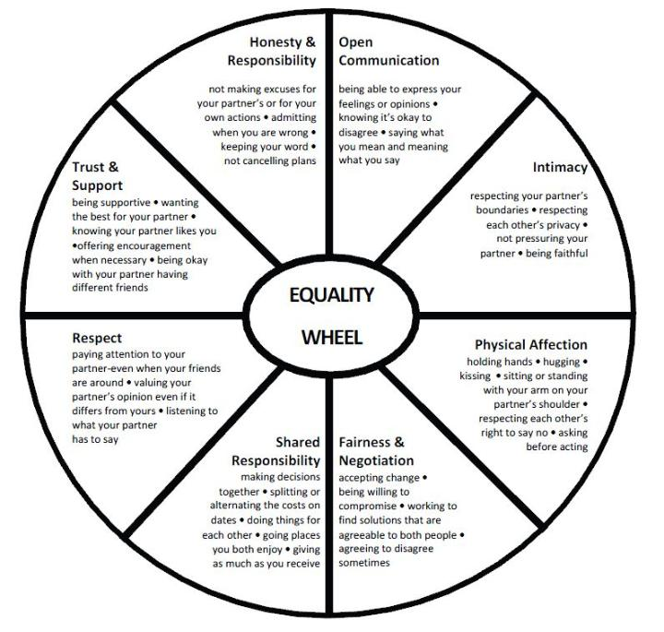 From http://www.stepupspeakout.org/youth/wheels

Next Week:
We will NOT be having group. Next week (Tuesday, March 19th), we will not be meeting because we will be taking a spring break. Our next meeting will be on Tuesday, March 26th at 2pm. See you then!

Additional Resources:
- This site – http://www.twoofus.org/index.aspx - can be really helpful for general information about relationships and dating. Particularly, this article - http://www.twoofus.org/educational-content/articles/the-art-of-compromise/index.aspx - talks about what it takes to compromise and how equal power leads to a healthy, balanced relationship.

- Oprah’s website on relationships - http://www.oprah.com/relationships.html - has a lot of great articles about relationships and couples. This article “How to save yourself from verbal abuse” - http://www.oprah.com/oprahs-lifeclass/Verbal-Abuse-How-To-Save-Yourself - is mostly aimed at females but can be helpful for males, too. It provides helpful tools to detecting verbal abuse and “saving your spirit.”

- http://vetoviolence.cdc.gov/datingmatters/# - is a website that offers a 1 hour and 20 minute training that will allow you to identify examples of teen dating violence and understand the consequences of teen dating violence. The training will teach you the risk factors, protective factors, warning signs, and challenges for seeking help for teen dating violence. We think this could be a great tool to have for individuals who would like to know more about relationship abuse and how to detect and cope with it.

