What We Learned This Week…
  - Community Choices

Connections
This week we learned a safe and effective way to use a condom. This can be a helpful tool as a condom can be used in addition to almost any other form of contraception.
Next, we played our own version of “Go Fish” with sexually transmitted diseases and contraception cards. Each card had a fact or piece of information on it about a type of STD or form of birth control. While we played, we learned about how to protect yourself from these infections and diseases.
Finally, we talked about basic sexual health and how to protect yourself and others. Attached to this newsletter are self-exams, breast and testicular. These are just one of the many things you can do to keep yourself sexually healthy.

Week 7 Sexual Health
Objectives:
- Know the proper way to use a condom
- Become familiar with the different Sexually transmitted diseases and infections
- understand the various forms of contraception and how to use them

Breast Self-Exam (McKinley Health Center)
Follow this procedure:
- Raise one hand up placing your hand behind your head and use the opposite hand to examine the breast.
- Using the pads of the middle three fingers, feel for swollen or lumpy areas. Move the fingers in small circles to feel the tissue beneath the fingers.
- Slide the fingers to the next area to be examined.
- Start at the outside border of the breast and work your way around the breast and into the nipple area. Avoid lifting the fingers from the skin to be sure you cover all areas of the breast. Also check under the arm and around the collarbone for lumps or swelling.
- Examine the other breast in the same manner.
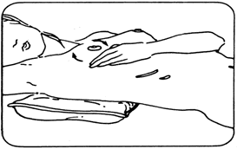
- Stand in front of a mirror and visually examine both breasts for changes in shape or contour by clasping hands behind head and press forward. Then move hands to hips and lean slightly forward. Observe for dimpling, puckering, flaky, red, or swollen skin, nipple changes or spontaneous nipple discharge.
- Lie down on your back. Put a small pillow or folded towel under the shoulder of the side you're examining. Follow the above steps, as you did in the shower. You may use lotion on your fingers to increase sensation and make it easier to slide your fingers across the skin. Change sides and repeat.
- Breast self-exam should be performed within 7-10 days after the start of a menstrual period. If you have had a hysterectomy or no longer menstruate, examine your breasts on the first day of each month. Doing the exam in the shower allows the fingers to glide easily over wet, soapy skin.

- If you find anything unusual - a specific lump or firm knot, nipple retraction, skin dimpling, or any other change that does not seem normal for your breasts, contact your health care provider right away. Breast self-examination is a valuable, preventive health practice for women. Developing a regular pattern will enhance your skills and help you notice changes.

Testicular Self-Exam (McKinley Health Center)
Follow this procedure:
- Stand naked in front of a mirror. Look for any swelling on the skin of the scrotum. It is normal for one testicle to be slightly larger and/or hang lower than the other (typically the left testicle hangs lower than the right). If the room is too cool it will be difficult to perform the exam. The exam is best performed after a hot bath or shower as heat relaxes the scrotum making it easier to spot any abnormality.
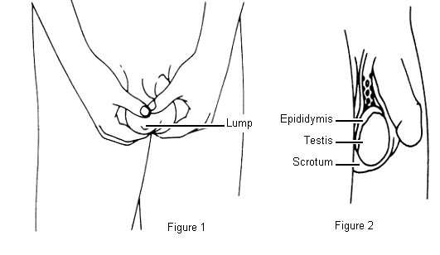
- Examine each testicle gently with both hands by placing your index and middle finger under the testicle with your thumb placed on top. Roll the testicle gently between the thumbs and fingers as shown in Figure 1. The testicle should feel like a hard boiled egg with the shell removed (firm, but not hard and smooth in nature). Feel for a small lump, about the size of a pea on the front or side of the testicle. These lumps are usually painless.
- Find the epididymis, a soft, cord-like structure (slightly tender to pressure) that stores and transports sperm, located on the top and back of the testicle as shown in Figure 2. This is a normal lump.
A testicular self-exam should be performed once a month after a warm bath or shower. The heat causes the scrotal skin to relax, making it easier to find anything unusual. The procedure itself is simple and only takes a few minutes. Performing the exam more frequently than once a month may cause you to miss a slowly changing lump, but if you do it once a month you will notice changes more easily.

For next week, we will be learning about sexuality and the law. We will learn more about internet safety and how to behave in a way that protects ourselves and others.

Additional Resources:
Women’s Health Information Handouts - http://www.mckinley.illinois.edu/Clinics/Womens_Health/womens_health_handouts.htm - These are a great tool that cover contraception, sexually transmitted diseases, overall sexual health, and more. If you click on the links to the right of each category, you can download the PDF of the handout.

Women’s Pap Test –
http://womenshealth.gov/publications/our-publications/fact-sheet/pap-test.pdf - This is a great resource for women to know why they need to get a Pap smear, how to prepare for one, and to know what to expect.

STD Info
http://www.std-gov.org/ - This is a great website that gives quick, simple, to-the-point explanations of all the sexually transmitted diseases. If you click on the disease on the left side of the screen, you can get a description of how it is contracted, what the symptoms are, and what exactly it is.

