What We Learned This week…

Week 9
Gender Roles
Objectives:
- Know the stereotypic gender roles in our society
- Understand the reality of gender roles and how people behave in them
- Comprehend some alternatives to typical gender roles and why some people would choose those behaviors

  - Community Choices

Connections
This week we talked about gender roles. We discussed the expectations of each gender and how those can impact us. We did this by finding pictures in magazines and cutting them out. We found stereotypical pictures of males and females and discussed their different gender roles in our society.
Next, we watched a video and discussed the video afterwards. We talked about any questions you may have about gender or the video. We talked about reality and how that differs from, and relates to, the stereotypes ingrained in our society about gender roles. In this newsletter, you will learn how men and women are sometimes treated based on these stereotypes.

 | Year | High School diploma or equivalent | Bachelor’s Degree
Average Male Salary | 2010 | $32,800 | $49,800
Average Female Salary | 2010 | $25,000 | $40,000

Information adapted from: nces.ed.gov/fastfacts/display.asp?id=77
Degree | Women’s median weekly earnings | Men’s median weekly earnings
Bachelor’s | $930 | $1,199
High school graduate, no college | $554 | $720
Information adapted from: www.catalyst.org/knowledge/womens-earnings-and-income
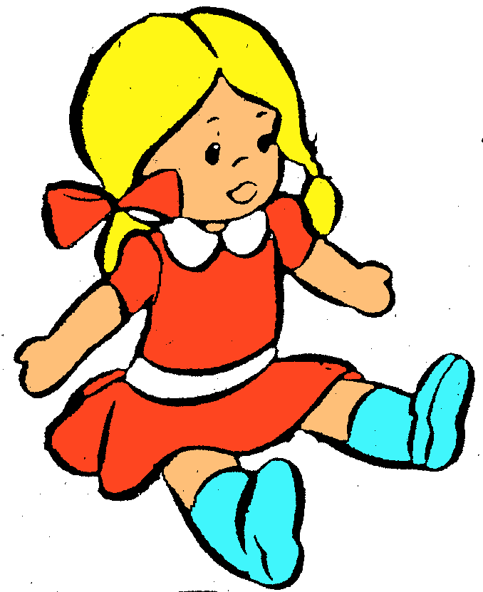
Jenny grew up with her two older brothers. She always played with dolls while her two brothers played with toy fire trucks and cars. When Jenny got to high school, she always wore make-up and dressed in skirts and dresses. Jenny was on the
softball team in high school when she really wanted to play on the baseball team with her brothers. When she graduated high school, Jenny wore high heels to the graduation ceremony. After she graduated, Jenny went to a prestigious college and
earned a degree, just like her brothers. Jenny got a
job after college that paid well, but she was not
making as much money as her male colleagues.


An Example of Typical Gender Roles


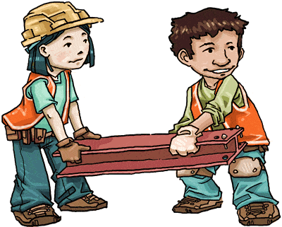
An Example of Typical Gender Roles
Bobby grew up in a family full of brothers and sisters.
He was the oldest of them all and felt like he had to be a
leader for his younger siblings. Bobby was always interested
in some of the more creative hobbies, like painting and
drawing but felt like he had to help run the household and
make money. Bobby’s friends always teased him about his interest in hobbies and encouraged him to join the sports teams but he did not have time. Bobby always worked many jobs to make money for the family and support his younger siblings.
Deep down inside, Bobby wanted to go to art school and become a painter. However, his family needed him so he stayed behind and worked late nights and early mornings to help support them. His sisters would cook him dinner while his mom would do would do his laundry and wash his work uniform.
Men and Women Are Very Similar
Physically, men and women both have 23 pairs of chromosomes. We share 22 of them. We only differ in one pair – the sexual one. However, our entire lives, we learn gender roles through social contexts. These roles are reinforced throughout our lives, shaping us into males and females. However, at the root of the matter, our physical bodies – chromosomal, anatomical, and hormonal – are very similar.
Additional Resources:

PBS’s new documentary, Makers: Women Who Make America, chronicles the Feminist movement from the beginning. Here is the link to the first video of the three-part series. This is a great documentary that has candid interviews, real-life clips, and shows the sequence of events from the Feminist movement - http://video.pbs.org/video/2336932877

This YouTube video has a brief, simple description about gender roles and stereotypes. It encourages everyone to step outside of gender role stereotypes if desired and pursue what feels comfortable. You can follow this link to view the video -
http://www.youtube.com/watch?v=nKqeECq2Si8

Next Week:
We will be reviewing what we have gone over throughout the course of the class. We will be answering any questions. If you have any, make sure to bring them!

