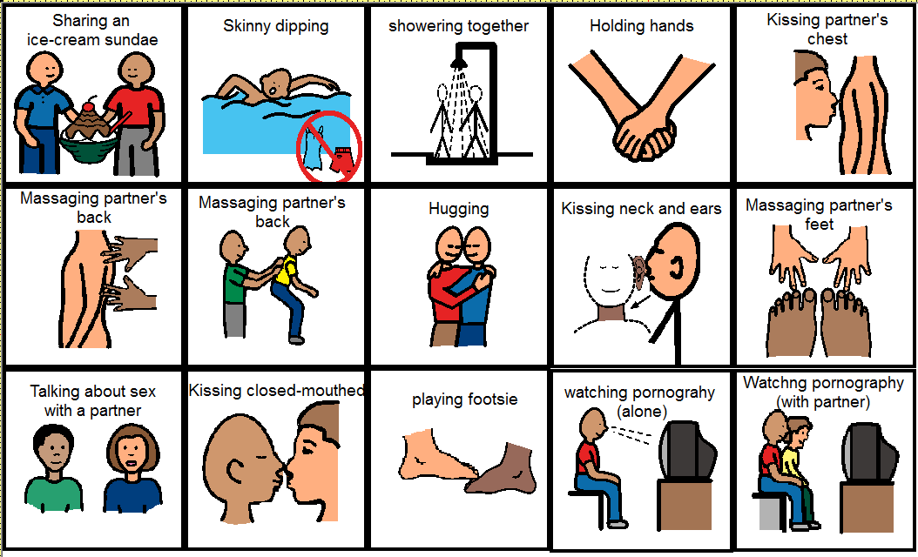
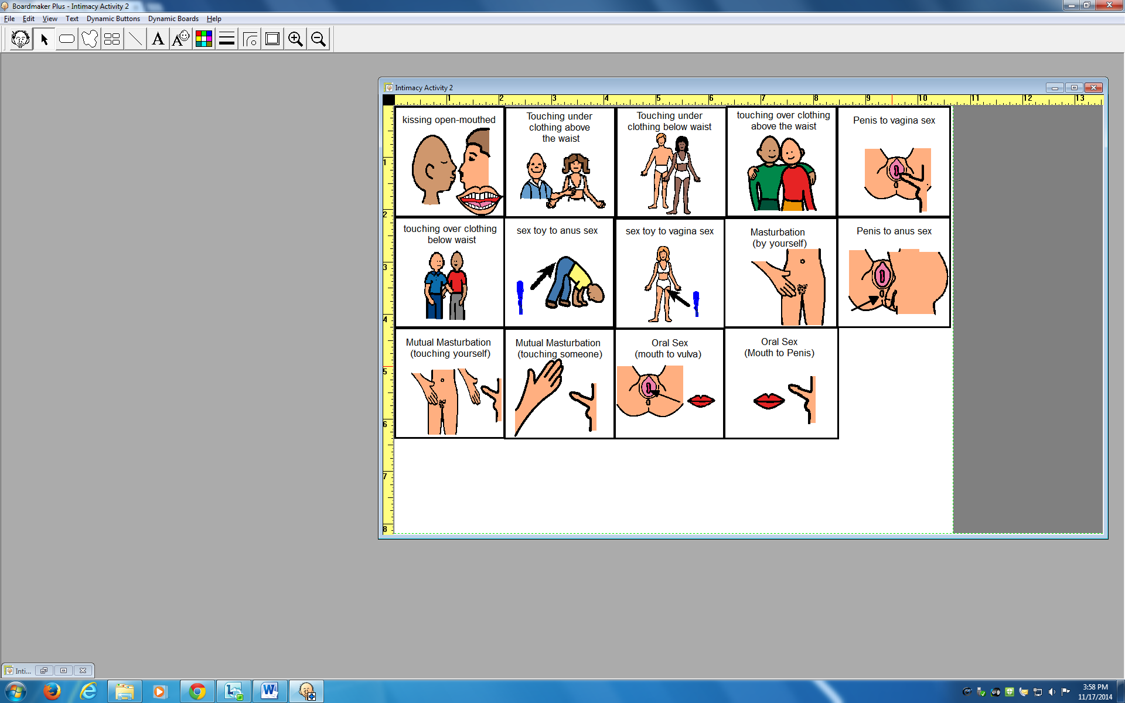

Outside of a Relationship
In a Serious Relationship
I Don’t Think I Would Ever Do This
In a Casual or New Relationship
Only If Married or in a Lifelong Partnership
Less Intimate More Intimate

