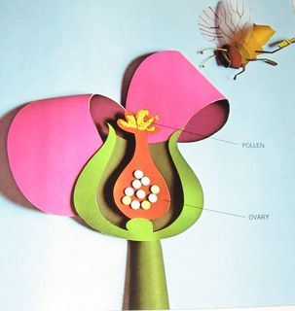
  Human Sexuality 101
    - Anatomy & Reproduction
  No class next week. Class resumes on 10/17!
the autism program at urbana-champaign |  | Objectives this week

Parts and Post-it Notes
We’ll start the group out by having them label body parts they already know. By starting out with safe, comfortable body parts students will be more prepared for sexual body parts or parts that may cause feelings of anxiety.

Terminology

10/17 …Body Image
- How I Feel About Me
- Body Image and the Media
- Positive Self Talk
- What did I learn?
We’ll introduce sexual terminology in written from and ask the students to say the words out loud. Between each word we’ll pause and they will have a worksheet with the question “I feel…” Reading a word and saying it are easier then looking at a body part so we are building their comfort level. Embarrassment and jealousy, especially, can be difficult emotions to recognize and express but are also really common in adolescence. This is structuring a way for them to think about and express their feelings. Each family makes their own choice about whether to use technical language or to use common language when referring to sexual body parts but kids really need to know both. We will have space to address the more casual names for different body parts but it will not be the emphasis.

Fruity Anatomical Model
The students will make anatomical models of the reproductive organs using fruit. As they make the model, we’ll talk about the function of each part. Again the fruit makes the concept a little more abstract and safe. This is a fun way to engage students in what is essentially a vocabulary task.

“Life’s Greatest Miracle”
We’ll use “Life’s Greatest Miracle” to explain the process of reproduction. We’ll especially emphasize the anatomical parts we have focused on thus far. This video will provide a more concrete example of the parts of the body. It will also help connect the parts of the body to their function. We’re only going to watch the first third of the video. It is available for free on NOVA’s website if your teen is interested in watching the rest. In class and in the video we emphasize that the reproductive system is designed to share reproductive information.

Activities this Week

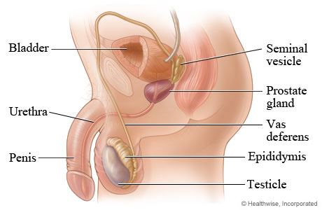
Terminology
We will expose students to anatomically correct terms for body parts involved with human reproduction. We expect students to be able to express their emotions when exposed to these terms when provided with support.
Reproduction
In addition to learning the names of the parts of the body, we expect that students will be able to connect the parts of the body with their reproductive functions. Some of the basic concepts are (1) women’s reproductive organs are mostly inside the body and men’s are mostly outside the body, (2) the reproductive system is a series of tubes and storage areas that connect to one another, and (3) these parts of the body produce genetic information and try to bring it together.

Conversation Topics- Parenting

We didn’t talk specifically about parenting, but it’s something that may be on the horizon. Wanting to be a parent is a natural urge that most people experience. These urges can be difficult to manage especially if the person needs some level of support to be independent. Because someone has a diagnosed disability, people often feel that they have the right to question that person’s ability to be a parent. What makes this especially tricky is that in some cases those concerns might be valid. You may be asking yourself the question, “Will my son or daughter be capable of having children one day?” Many people with disabilities are capable of being excellent parents. No parents can raise children 100% on their own; everyone needs help sometimes. On the other hand it is easy to get wrapped up in the joys of having a child without thinking of all the sacrifices and responsibilities. What are your hopes and fears about your child as a possible parent? What do you need to do to support your child with making the best choice for them?

Conversation Topics- Birth Control

We did not talk specifically about birth control and you may think that your child is not sexually active so birth control is not something that you have to worry about. There are a few things to keep in mind.
1) You may not always know if your child is sexually active or not. Ideally you and your child would share similar values about the timing of sexual activity and they would feel comfortable coming to you. However, young people sometimes go to great lengths to hide their sexual activity from their parents. How do you communicate your values about sexual activity?
2) Although it’s not common, one of parents’ greatest fears is the possibility that their child could be taken advantage of. Furthermore, despite education they may not fully grasp the implications of their choices. How do you promote safety without instilling fear and shame?

Additional Resources
Asdsexed.wordpress.com

A Birth Control Resource
TeachingSexualHealth.ca has a nice webisode about how to address contraception with your child (in addition to other resources).
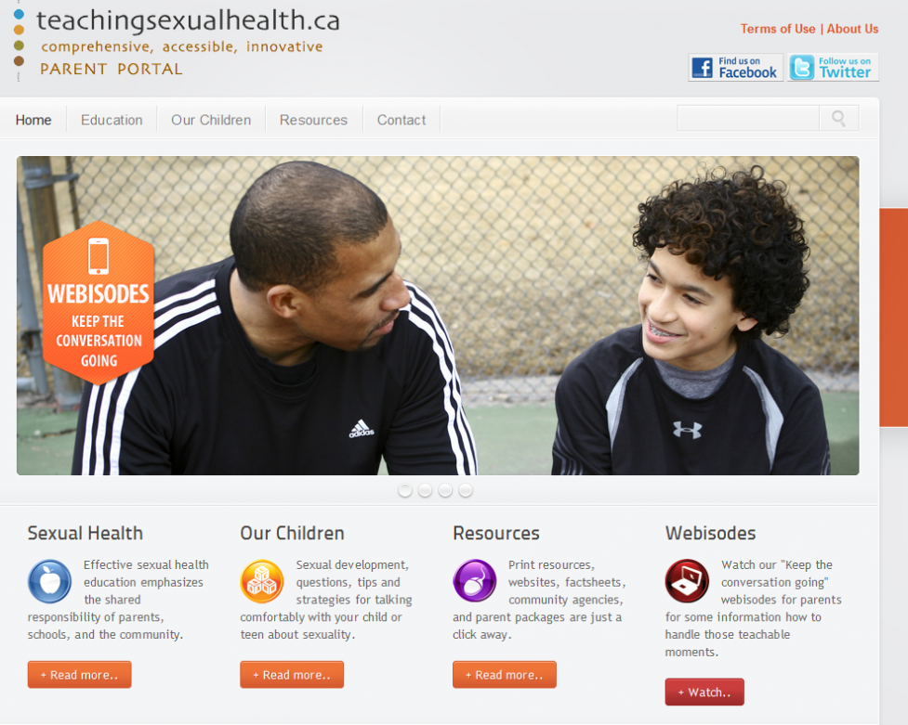

Individuals with Disabilities as Parents
AutismNow.org has a lot of great resources for families Autism including several webinars about sexuality topics. They have webinar presented by self-advocates about being parents. Below is one of the slides from the webinar.
There is also a documentary called Is Love Enough? that you may find interesting. This movie shares one couple’s story.
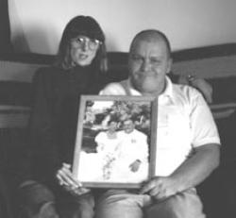

What Other Parents are Going Through
AThinkingPersonsGuidetoAutism.blogspot.com is a blog by people with Autism, family members, and professionals. Most of the articles are not about sexuality but I find those that are to be very insightful.
