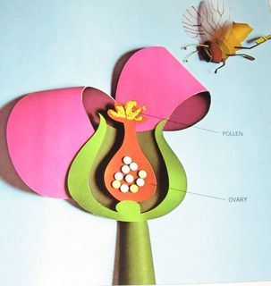
  Human Sexuality 101
    - Power in Relationships
the autism program at urbana-champaign |  | Objectives this week

More Power and Less Power

For the Future
- We’ll be sending home a booklet that includes most of the information we’ve covered and some additional information. This can be a good tool for continuing the learning process at home.
We’ll brain storm the benefits and the drawbacks to having more or less power in relationships. We’ll visualize using a simple grid. 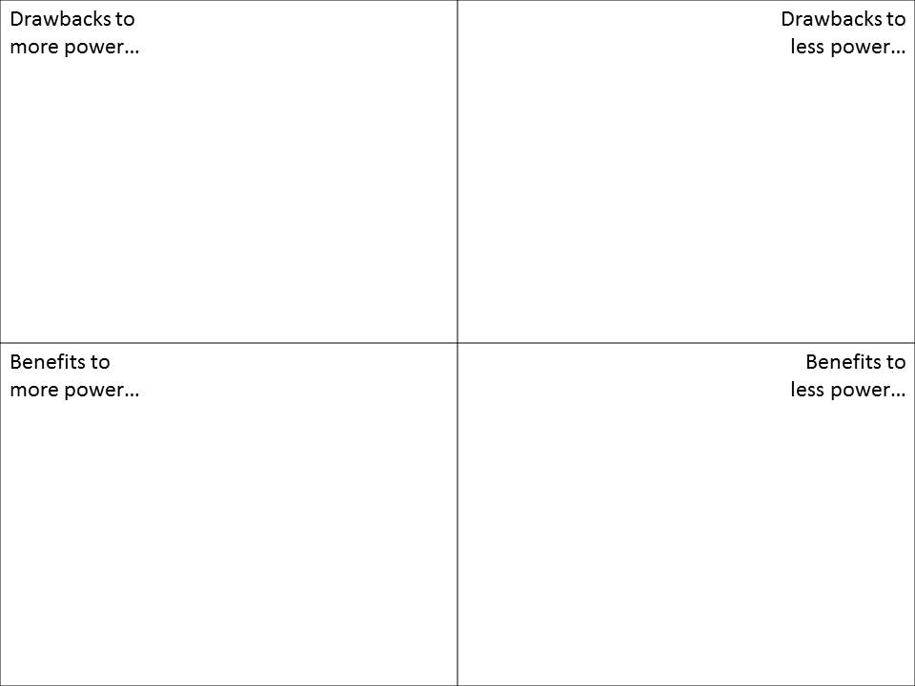After our initial discussion, we’ll talk about the difference between balanced and unbalanced relationships. The take home message is that in a balanced relationship sometimes you have more power and sometimes you have less power, but for the most part it is balanced. If a relationship is unbalanced having more power or less power can be a problem.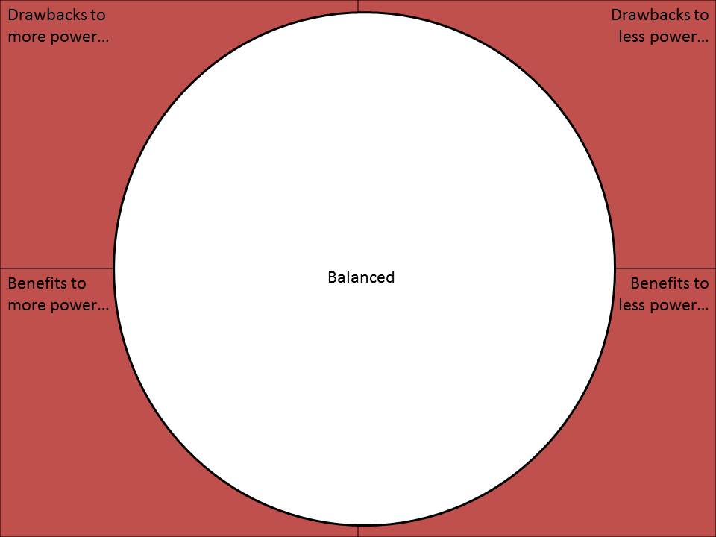

What is Power in Relationships?

This week will be thinking about questions like, “Who makes the decisions?”, “Who gets listened to?”, and “Who is in charge of what happens?” In introducing these questions, we’ll introduce the concept of power in relationships.

Brainstorm

We will begin the discussion with a brain storm of different kinds of relationships (eg. friends, parent-child, teacher-child). As we do so, we’ll discuss and point out the ones that have obvious different power levels.

Would you rather?
We all feel different with different levels of power and control. This activity helps us tune into how much power and control we prefer in relationships.

Activities this Week

Understanding Power Dynamics
Although there are power issues in every human relationship, serious inequality is common in sexual relationships between adults and young teens. In these relationships teens’ lack of power to negotiate in their own best interest leaves them vulnerable to unfortunate consequences, including lowered self-esteem, pregnancy, sexuality transmitted infections, and abuse. This lesson uses a variety of strategies to 1) raise consciousness about the problems of power and powerlessness in relationships. 2) It suggests that in healthy relationships, each partner respects the rights of the other equality in making decisions regarding the relationship.
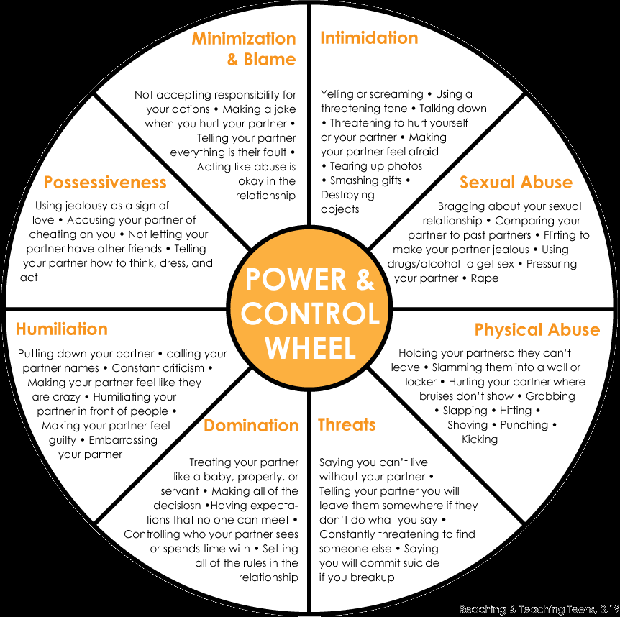
Strategies
Students will identify situations and relationships that make a person feel powerful or powerless. 1) Participants will identify 3 characteristics of a healthy relationship. 2) Participants will identify 3 “warning signs” of a potentially unhealthy relationship.

A lot.
The Sexuality Information and Education Council of the United States propose comprehensive guidelines for the developmental messages associated with sexuality topics including romantic relationships and dating. I’ve provided some examples of some of the important messages they suggest in this area.
Dating is when two people who are romantically attracted to each other spend their free time together.
When children become teenagers, they spend more time with their friends and may begin to date.
Some adults, including single parents, may date.
Both teenagers and adults may have romantic relationships but readiness and interest in dating vary among individuals.
Before people commit themselves to a relationship, they may want to be friends, spend time together, and get to know each other well.
Young people may use many different terms to describe dating and romantic relationships.
Not all teenagers or adults date.
Parents often decide the age at which their children may begin dating.
People of different races, ethnic backgrounds, and religions sometimes date each other.
People date for a variety of reasons such as companionship, to share an experience with someone, friendship, intimacy, and love.
Both girls/women and boys/men can show interest in a dating partner and initiate dating.
People date in different ways such as couple dating, double dating, and group dating.
When dating involves expenses, either person or both people can pay but paying for a date or giving gifts does not entitle someone to any type of sexual activity.
Sometimes people in dating relationships may be physically or emotionally abused by their partners which is called “dating abuse.”
There are organizations and counselors who can help teens and adults who are in an abusive relationship.
Ending a dating relationship can be painful.
Dating can be a way to learn about other people, about romantic and sexual feelings and expressions, and about what it is like to be in an intimate relationship.
Dating partners may choose not to follow traditional gender roles in their relationships.
Dating relationships can be enhanced by honesty and openness.
One person cannot meet all of the needs of his/her dating partner.
Responsibility for the quality of the relationship is shared by both dating partners.

Additional Resources

What do young people need to know?
These are a few additional resources that can be found in TAP’s library.

Mike’s Crush
Videos that demonstrate healthy and unhealthy high school relationships.
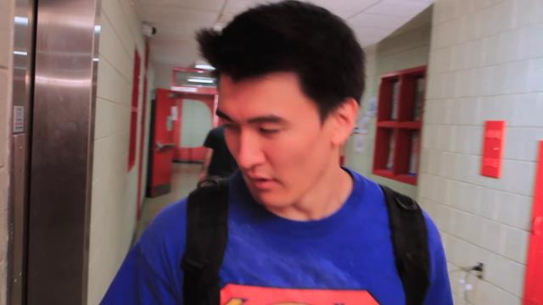

Intimate relationships and Sexual Health
A curriculum for teaching adolescents/adults with ASD.
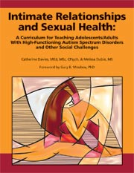

Circles
A curriculum for teaching intimacy and relationships with a focus on social boundaries.

